Xpress Testing Deep Dive
Date: 16/04/2025
SME(Discover) :

Objective of the Discussion
- Representation of MANIAC model in lower env (non-prod).
- Types of MTIs being used in the Test Suits.
- DCI Transaction Switching.
- Xpress System Architecture.
- Testing Tools
  - Legacy Test-Tool
  - Cucumber BDD
- Test Data Management.
- Test Configuration Data.
- Test Configuration/Connection Management
- Test Environment/ Regions.
- Cucumber Test Execution Flow.

Representation of MANIAC model in lower env (non-prod).

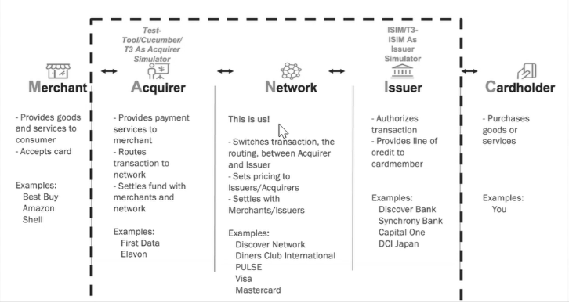

Non-prod MANIAC Model Representation
- The model starts from the Merchant.
- In testing (Express, Hydra, etc.), the Merchant is just a placeholder for acquirers.
Starting Point
- We begin testing from the acquirer, not the Merchant.
- Example: Best Buy or Walmart as Merchants have devices acting as acquirers.
Acquirer Role
- The acquirer takes transaction information and passes it to the network.
- Testing tools (legacy test tool, Cucumber, T3) simulate the acquirer.
Network Processing
- The network processes the transaction information received from the acquirer.
Issuer Simulation
- In Nonprod, we don't use real issuers; we simulate their behaviors.
- ISIM acts as an issuer simulator.
- Future plans include using T3 as ISIM.
Overall Nonprod Model
- This model is used for testing the Manhattan model.
- Tools and simulators replicate real-world behaviors.

Payment Service MANIC Model

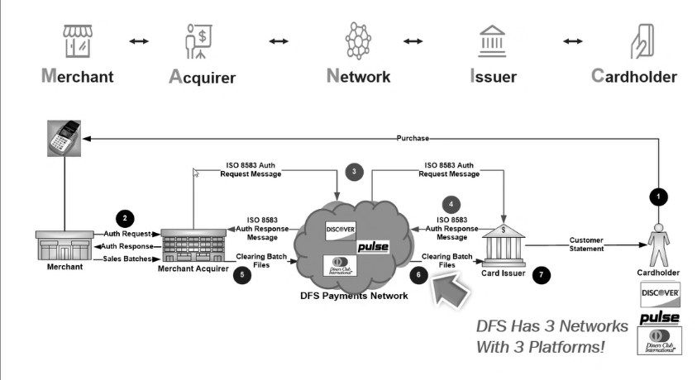

Authorization and Settlement Process – Overview
This diagram explains the complete flow of a card payment transaction, covering both authorization and settlement processes. This is fundamental to understanding how credit and debit card payments work behind the scenes.

Step-by-Step Explanation
- Initiation by the Cardholder:
A customer (Cardholder) initiates a transaction by making a purchase at a merchant location. This could happen in several ways—via a POS (Point-of-Sale) terminal, online platforms, digital wallets, or even smartwatches.
- Merchant to Acquirer:
Once the transaction is initiated, an ISO message is generated from the merchant’s terminal. This message is then sent to the Acquirer, which is the financial institution or bank where the merchant holds its account.
- Acquirer to Network:
The Acquirer forwards the ISO message to the appropriate Payment Network (e.g., Discover, Visa, MasterCard, Amex). The choice of network depends on the card’s branding and the agreements between the issuing bank and the network.
- Network to Issuer:
The network then routes the transaction to the Issuer, which is the bank or financial institution that issued the credit or debit card to the cardholder.
- Authorization Decision:
The Issuer evaluates the transaction based on several criteria—available balance, card status, fraud checks, etc.—and makes an approval or decline decision. This decision is sent back through the same chain: from Issuer → Network → Acquirer → Merchant.
- POS Confirmation:
The result of the authorization is displayed to the customer via the POS terminal or payment screen, along with a receipt.
🔹 Note: At this stage, no actual money has been moved. The amount is simply blocked or held on the card.

Settlement Process (Post-Authorization)
- The actual movement of funds occurs during the settlement phase, which takes place later—usually at the end of the business day.
- Both Acquirers and Issuers submit batch files:
  - Acquirer Batch Files contain all merchant transactions.
  - Issuer Batch Files contain transactions authorized by the issuer.
- The Network (e.g., Discover) performs reconciliation:
  - It matches transactions in both batch files.
  - Validates the amounts.
  - Handles any mismatches or disputes.
- Once reconciliation is successful, the network facilitates fund transfer from the Issuer to the Acquirer.
  - The Acquirer then credits the merchant’s account.

DCI Transaction Switching Overview

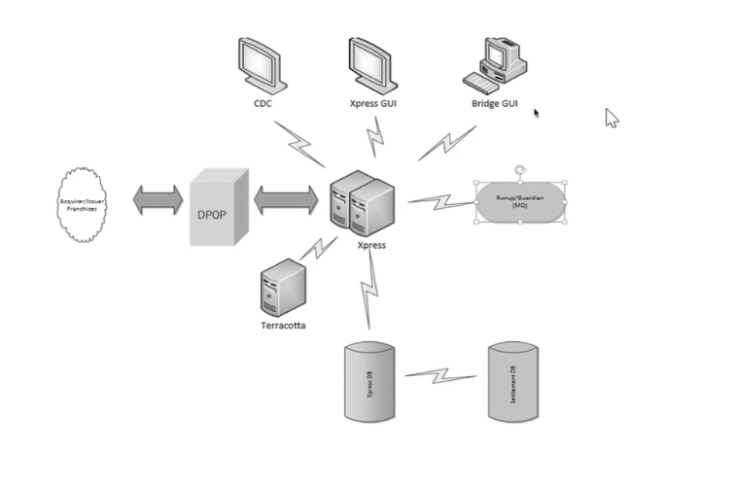

- Express App and D-POP:
  - The Express app receives messages from D-POP.
  - Previously, there was a change where D-POP was shown as Bridge, but now it's back to D-POP.
- Connections and Data Flow:
  - D-POP connects to Express.
  - Express gets configuration data from CDC and Express GUI.
  - Express is also connected to Terracotta and Express DB.
  - Express DB is connected to Settlement DB for settlement purposes.
- Obsolete Components:
  - The Bridge GUI is obsolete and not discussed further.
- Core Data Configuration (CDC):
  - CDC stores all data related to DCI participants, including metadata.
  - This data is used when onboarding new participants.
- Express GUI:
  - A collection of applications, including DCAP, which is the main app for Express.
  - DCAP monitors the health of Express nodes (server instances).
  - It shows if nodes are up, down, or healthy.
  - Defines cache tables for Express, which are cached during system startup.
  - Defines connection flows in the Express ecosystem.
- Toolbox and Gateways:
  - The toolbox defines server connections for transaction flows.
  - DCAP also defines transaction flows using gateways.
  - Gateways have IP and port combinations for routing transactions for participants.

ISO 8583 Standards
Key ISO 8583: 93 format message types:
- 1100//1110 (Authorization & Authorization response)
- 1120//1130 (Authorization Advice & Acknowledgment)
- 1200//1210 (Financial Transaction)
- 1304//1314 (File Action request & response)
- 1420//1430 (Reversal Advice & Acknowledgment)
- 1624//1634 (Administrative Advice & response)
- 1804//1814 (Network Management)
Xpress System Architecture Diagram:

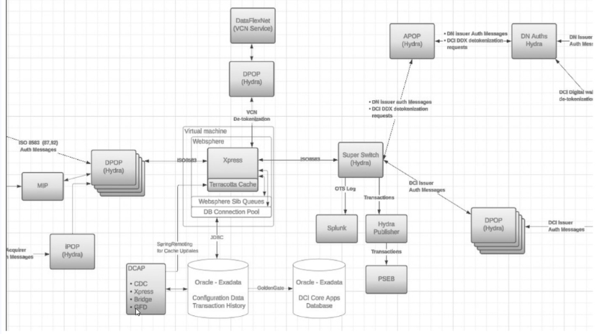

Testing Tools: In-house Legacy Test-Tool

- As an Acquirer:
  - Send transactions to the Acquirer Request file.
  - Use the Online to Switch tool in Legacy Test Tool or Issuer Mode.
  - Test transactions from Issuer to Acquirer using the Online to Switch tool in Issuer Mode.
- As an Issuer:
  - Simulate transactions based on file data.
  - Configure settings for sending files in Legacy Test Tool or Issuer Mode.
  - Set simulation parameters based on expected responses from Host/Acquirer.
Steps
- For Acquirers:
  - Validate transactions using the Acquirer_DCTM.log file.
- For Issuers:
  - Validate responses based on system file data.
Testing Tools: Cucumber BDD
Roles and Functions:
- As Acquirer:
  - Sending transactions based on the tests defined in the feature file.
- As Tester/Transaction Validator:
  - Performs test validation based on application transaction logs.
  - For applications, also performs end-to-end validation for the test transactions.
Use Cases:
- Client identification for UAT (User Acceptance Testing), pre-need, and test runs & systems.

Test Data Management
- When using Test:Tool for functional testing, as acquirer, all test-transaction data resides in .dat file.
- These .dat files contain comma-separated data for a test case in a single row.
- All .dat files are under version control using GIT.
- For Main Suit, we have different Data Sets being used for Xpress Regression for different Xpress environments like RED1, REG2, RED3, RED9.
"RED1","REG2","RED3","RED9"

Sample.Dat file
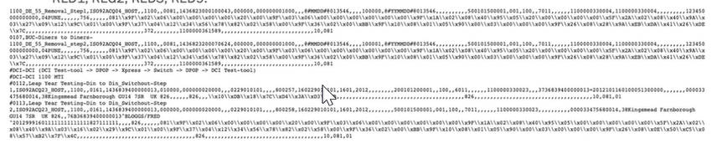

- When using Cucumber for functional testing, as acquirer, all test-transaction data resides in feature files.
Test Configuration Data
Rule Template:
- Simulates business flows from the Issuer's perspective for different types of transactions.
Configuration Scope:
- Acquirer Side: Connection configuration data from Acquirer Instance to the MDOP.
- Issuer Side: Connection configuration data from Issuer Instance to the MDOP.
Configuration Details:
- The configuration is the same for both Acquirer and Issuer.
- Includes ISO flows like Mastercard, DCI, and Visa.
Commitments:
- Run all details of ISO flows with different gateways on both instances.
- Ensure all flows are supported by their gateway, either ADF or EBDIC.

Test Configuration/Connection Management
Test Connections/Configuration management is done by an In-House application called Toolbox. ToolBox provide the connection/routing information for a type of transaction to application.
ToolBox expose an API call to fetch the details of swim lane/environment being used for the test execution.
The swim lane/environment info is being used to send the transaction to correct DPOP/APOP and fetching the logs.
Below is the example of Test-Tool (RWLD620) to DPOP Connection for RED1 Swim lane/Environment:
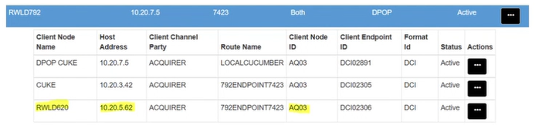

Test Environment/Region
CI (Component Test Cases):
- Purpose: For scrum teams to run standalone tests of the Express application during development.
- Environment: Express app only, no Hydra involvement.
PA (Pre-Integration Test Environment):
- Environment: Deployed in DSL (Data Services Layer) region, with one instance of Express (Node 1) currently working.
- Plan: Adding Node 2 and Node 3 to DSL to enable parallel testing.
- Usage: Used for testing before moving to the PAT environment.
PAT (Pre-Production Acceptance Test Environment):
- Critical Environment: PAT is crucial for testing, with two sub-environments: Red One and BM.
- Red One:
  - Used for release testing and regression testing.
  - Has connectivity with external parties.
  - Used for SIT (System Integration Testing).
- BM (Benchmark Environment):
  - Has two instances of the Express application (Node 2 and Node 4).
  - Used for performance testing.

Summary :
- Multiple Environments: CI, PA, and PAT environments serve different purposes in the testing process.
- Parallel Testing: Plans to enable parallel testing in the PA environment.
- Critical PAT Environment: PAT environment is crucial for testing, with Red One and BM serving different purposes.

Perform Functional Testing:

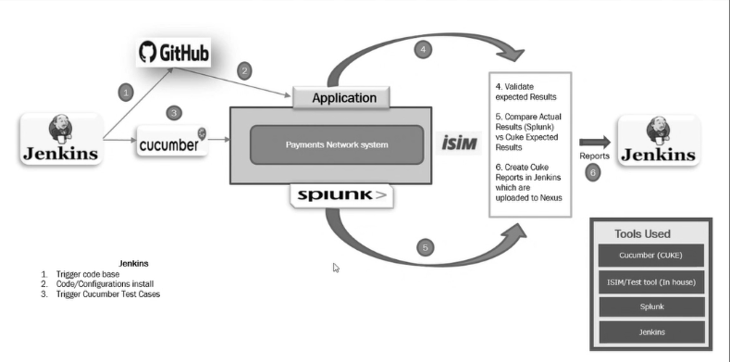

Test Flow:
- Triggering Tests:
  - Tests are triggered from D-POP in the yellow region due to constraints on sending traffic to A-POP from outside IP addresses.
- Deployment:
  - The pipeline starts with pulling the branch and deploying the application.
- Configuration:
  - Basic configuration is done, and the latest configuration is deployed to the ICM (Integration Control Module) instance.
- Testing:
  - Cucumber sends requests to the Payment Network System (Express) through D-POP.
- Reporting:
  - Reports are generated and sent to Nexus for storage and analysis.
Summary:
- D-POP:
  - Used to trigger tests due to firewall constraints.
- ICM Configuration:
  - ICM configuration is being updated as part of the pipeline.
- Reporting:
  - Reports are sent to Nexus for release regression testing.

Test-Tool Test Execution Flow